EVP - Radio Sweep Recording Process

Author: Michael Edwards. Last updated: July 18, 2009

 |  | Page
1.0 | Overview | 1, 2
2.0 | Receipt of Client/Family member Information | 2, 3
3.0 | Client/Family Member Document | 3
4.0 | Arranging an Appointment with the Deceased Victim | 3
5.0 | Setting up the Radio and Recorder for a recording session | 3,4
6.0 | Begin the Recording Session | 4,5,6
7.0 | Uploading the recorded file to your computer | 6,7,8,9
8.0 | Preparing your file for File Segmentation | 9,10
9.0 | De-noise files for Transcription | 11,12
10.0 | Transcribing Segmented and De-noised files | 12,13,14,15
11.0 | Preparing CD’s for Key Files to send to Client/Family members | 15,
12.0 | Mailing the CD’s of the Recordings to Client/Family member | 16
13.0 | Client/Family member should use Audacity to listen to the files | 16,17,18
14.0 | Radio Hack to Enable Recording EVP | 18

1.0 Overview:

Speaking to the dead to obtain messages from our loved ones is nothing new, as a good number of Psychic Mediums have been providing this assistance this for years.

I am neither a Psychic nor a Medium, but I have developed a skill in capturing better EVP “Electronic Voice Phenomena” messages from the deceased using manual sweep and/or altered Digital Sweep AM radios.

So how do deceased victims get their messages to come through our hacked radios?

It is believed somehow when the radio is scanning stations, the deceased use fragments of speech from the radio traffic to form words.
- So if you are recording with lets say your deceased father, you may get messages that can sound male, female, young, old, animated, and even in the form of whispers.

So when I turn my altered Radio Shack, model 12-469 AM/FM digital radio on, set it to AM and run the scan continuous, these entities/deceased victims supposedly use fragments of the radio sound to form words which I record on my Olympus Digital recorder, and these words with exception to some radio station traffic, are responses to my questions I have asked them.

Key to note about using AM/FM radio to capture voice responses to questions, and that is some radio traffic with this 12-469 model radio as well as other altered AM/FM radios does seep through showing up on the recorder. Regardless, what are important to the trained/experienced “Radio EVP” recorder are the following:
- Answers/responses to direct questions asked: For example, if I ask a deceased family member to tell me the name of the family dog, and I get a response that says “buy insurance at Geico”, “Burgers”, “Bush”, I am quite confident that this is radio traffic, and not a spirit. On the other hand, if I hear the word “Jake”, which is the name of the family dog, I feel more confident that is a genuine message, especially if I can replicate that same answer later on when I ask all my questions over again, which I try to do for every recording.

This guide outlines step by step, from the moment I get my client/family information to how to create and record a spirit response work sheet, how to segment and save .wav files, and how to prepare CD’s to send key recordings to the client/family member either through e-mail or the US-mail.

Feel free to visit my yahoo web group http://tech.groups.yahoo.com/group/SDWR-SpeakingToTheDeadWithRadios-/

2.0 Receipt of Client/Family Information

Receipt of client/family information can come as follows.
- The information comes to me either by phone or by an e-mail from a client/family member requesting assistance.

3.0 Client/Family Document

For the client/family document, I also use Microsoft Word.

The client/family document is a one stop shopping document for me, as well as the client/family member or any other party that reviews it.

In this document are all information I have been given about this client/family member from the client and/or web pages that include news about the recording subject.

4.0 Arranging an Appointment with the Deceased.

So how does one arrange an appointment with a deceased person? You can not send them an e-mail or call them on the phone.

The night before I initiate a recording, I pray to my guardian angel and ask they find the deceased person, and let that person know I want to do a recording with them the next day in my office, and at what time.

I do all my recordings at 8am, Monday through Friday. Eight AM is best for me as there appears to be less AM radio traffic at that time.

5.0 Setting up the Radio and Recorder for a recording session

As I enter my home office, the room in which I perform my recordings, I first set up my Radio Shack model 12-469 radio and external speaker model 21-549 on my desk away from my computer.

This is important as placing the radio too close to a computer or other electronic devices seems to cause more static/background noise than normal.
- Please note if there is foggy weather, this can also cause issues with additional noise as I have found.

Next I turn on the Olympus digital recorder and delete the previous day’s recording.

After all files are deleted, I take a moment to introduce myself to whomever may be in my room, giving them a brief synopsis of who I am, and what I do, and that for today’s recording that I will be talking to deceased person xyz.

Next, I will stress the importance of the meeting/call, and tell the deceased person what I need answered today and why.

After these preliminaries are complete, I will turn the recorder on and set to record first, and then turn the radio on, and set to scan.
- I made the mistake once and turned the radio on first, and not the recorder, and lost an important message at that instant.

6.0 Begin the Recording Session

As mentioned before. I personally prefer to record from 8AM to 9AM, Monday through Friday.
- I stop at 9AM, as that is when I need to start work. I work from home.

With the radio on, and the recorder running, I first start off by asking “are there any spirits with me today?”, and I keep repeating this question until I get a “Yes” response.

Next if I have any photographs of the deceased person’s family members, I will ask a confirmation question by holding the photo up and ask what relationship the person in the photo is to them. For example if the photo is a husband, I would expect to get a message of husband, and so on.
- Please note that talking to spirits using a radio is no different that talking to a person on the internet. You have no idea who you are talking to, and if you have information or photographs use these in your recordings to confirm to make sure you are speaking to the right entity.

.

Below is an example of what a new first day recording session might pan into.

Client/Family Recording Example:
- Good Morning, is Jane Doe here today? Answer = yes
- Jane Doe, your son Greg asked me to contact you. Do you have a special message for your son? Response = I love you

For my recordings, I ask no more than two questions, and I only give them 10 to 15 seconds to answer that question. You will be surprised how many compressed messages show up in that 10 second file. Always remember the longer the recording is, then you have allot of file segmenting, file cleaning, and then file transcription to do thereafter. For me, I have limited time since I do work a full time job, so I only have a couple of hours in the morning, and hour at lunch, and maybe an hour before bed to complete this tedious task.

Just before I ask my next question, I say the word “OK”. This will be my segment cut off when I segment each question/answer into its own .wav file.

As I near the end of my recording session, I tell the deceased spirit that I am going to end the recording session, and thank them for coming.

7.0 Uploading the recorded file to your computer

Before I upload my recorder “.WMA” file to my computer, I set up a folder. Let us imagine this is a brand new case, so for each new case, I will set up a folder called “Jane Doe”, then in that folder I will set up a sub-folder called “Jane Doe June 6 2008”, and for every recording going forward with this case, I will create a new sub folder in the same format.

Please note that this step in the process may be different for some, as not all “recorders” record with a digital recorder. Some of my colleagues actually record directly from their computer.

For the purposes of this guide, I will proceed to outline next steps using a digital recorder.

As mentioned before, I use an Olympus digital recorder, Model WS 100. This recorder is equipped with a cable to upload the “.WMA” file from the recorder to a folder.

Note above I have created a folder called Jane Doe, and a sub-folder called Jane Doe June 6 2008.

With the Olympus recorder, to ensure the file is not corrupted, you need to ensure the recorder is set in the off position. Next you pull the sleeve off as noted in the manual, and plug in the cable, and then plug that cable into the computer. A ping will announce on your computer, and from here you follow the instructions per your model computer and move or drag the “.WMA” file to the sub folder.

For example, see below.

1. Create your main folder.


2. Upload your recorded file per recorder manual instructions
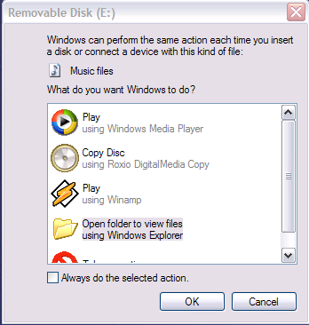

3, Click on the Open Folder to view files, and click OK. Note your computer may be different.

4. For the Olympus recorder, open folder DSS_FLDA



5. Ensure that sub-folder Jane Doe June 6 2008 is open, and drag the “.WMA” file into the folder.

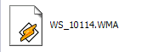

6. See below it now sits in the sub-folder

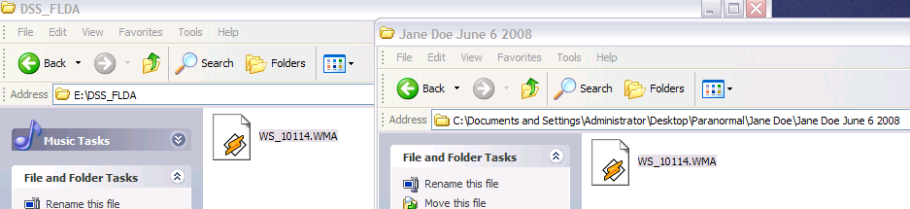

- Next you need to change the “.WMA” file into a “.WAV” file

I use a program called Switch 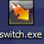 NCH Swift Sound Software. You can go to the web and get a free download.

- Inside Switch, press add file as below to capture the “.WMA” file from the sub-folder

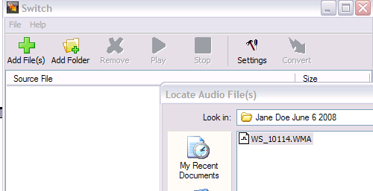

- Once the file is added, set the output format to “.wav”, and set the output folder to the sub-folder. You need to ensure you redo the output folder every time as you will/can add the newly converted file into the wrong sub-folder.
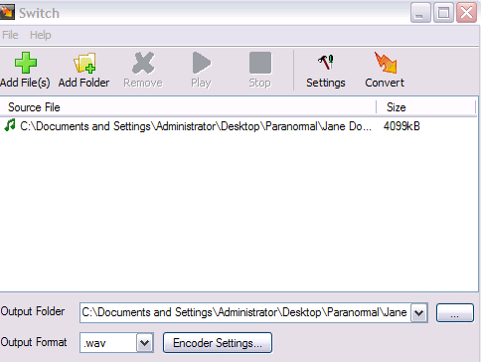

- Press the convert button 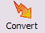

Doing so, converts the file. Note below, that you still have the original “.WMA” file and the new “.wav” files in your sub folder.
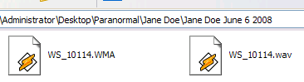

8.0 Preparing your “.wav” file for File Segmentation

Here is how I segment.

First I use a Microsoft program that is added to my computer called Sound Recorder. Any computer that has Microsoft Windows should have this feature.

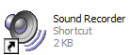
Next I click File, Open, Browse for my “.wav” file inside sub-folder Jane Doe June 6 2008, and open it up.

What I am about to show you is my personal method for file segmentation, but you may feel it necessary to devise your own, and you may even have/know a better way.
- Please share, as I am always looking for a better way.

Next, I rename the “.wav” file to Jane Doe June 6 2008, and thereafter, I rename it again to TEST Jane Doe June 6 2008.
- It is the TEST file that I will use to do my segmentation, and when complete, I just delete that file.

Now that I have TEST Jane Doe June 6 2008 open, I start to listen to each question and answer. At the end of each answer, I stop the recording where I want to segment.

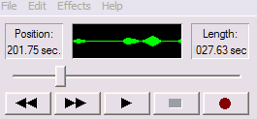

Next, I click Edit, “delete after current position”, and the click OK

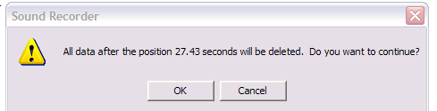

Next, I do a File, Save as, and note below what I do.

I want to remove the TEST from the file name.

Before

After,

Then, I want to add a number to indicate this is the first segmented file in the recording.

After the above file is renamed as above, I click save.

Next I reopen file TEST Jane Doe June 6 2008, and move to my last position where file 1 ended, and then I click Edit, delete before first position, and save. Now I can proceed to segment the next question/answer in the same manner until the main file has been segmented into individual files...

After all segmentation is complete, I delete the TEST file.

Below is an example of what I should have after I have segmented the main TEST file into smaller segments.

Sub-folder Jane Doe June 6 2008 should have a set of files as below.

Jane Doe 1 June 6 2008
Jane Doe 2 June 6 2008
Jane Doe 3 June 6 2008
Jane Doe 4 June 6 2008
Jane Doe 5 June 6 2008
Jane Doe June 6 2008

Note the last file is the main file uploaded from the recorder.

.

9.0 De-Noise files for Transcription

The next step in the process is to clean up the files, removing the static and background noise, so you can better hear any spirit voices that were recorded.

I personally use a program called Clear Voice. http://www.speechpro.com/eng/products/noise-cancellation-sys/clear-voice/

Not having an IT or technical background, I use the simplest path to de-noise, and I have yet to test all the other features of this tool. This program is about $65.00 USD and can be downloaded from the web.

With Clear Voice, I open up the program, and press the Load Source button to load the file from Jane Doe June 6 2008 sub-folder, file Jane Doe 1 June 6 2008.

Next I set the Noise Reduction Degree to 1 (soft) – 8 db.

For me this provides the best reduction in noise, so I can hear the recorded voices with good clarity.

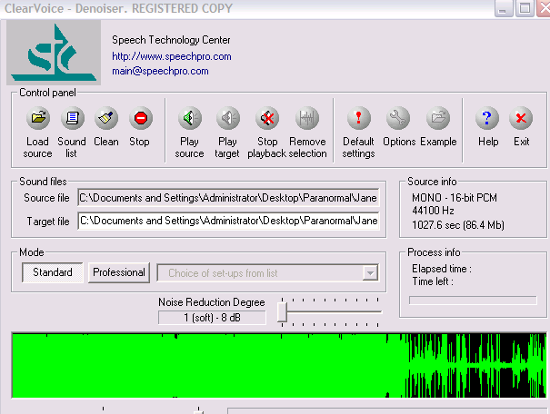

Next, I press the clean button, and after the file has been cleaned, I load the next file and repeat the process until all the segmented files are cleaned.

After the file is cleaned, it will be named as Jane Doe 1 June 6 2008_CLR.wav.

It is this file that I want to use in transcription, and not the original segmented file.

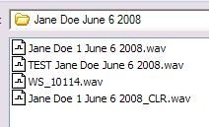

10.0 Transcribing Segmented and De-noised files

The next step in the process is to transcribe each segmented and cleaned file.

I use Microsoft Excel worksheets to record my file transcriptions.

Remember back in section 8.0 “Preparing your files for segmentation”; I saved each file with a number. The reason in saving these files in a sequential number format is to help facilitate transcribing the files in the order in which they were recorded.

When transcribing each file, I open the file in Audacity. http://audacity.sourceforge.net/

Audacity is free, open source software for recording and editing sounds. It is available for Mac OS X, Microsoft Windows, GNU/Linux, and other operating systems.

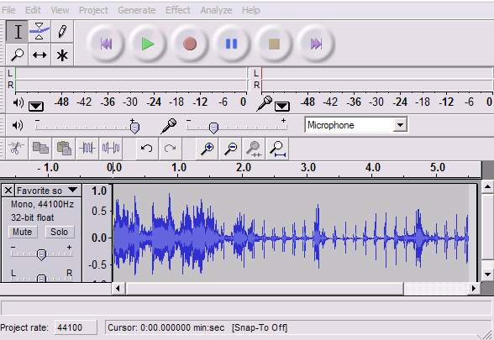

In Audacity, I block off small segments of recording and listen to it. For low sounding voices, I click on “Effect”, then select “Amplify”, and if the voice is too fast, I select in this same menu “Change Speed”.

For voices that are garbled and do not sound like a real word/text, I select “Reverse”, and sometimes there are messages there when reversed.

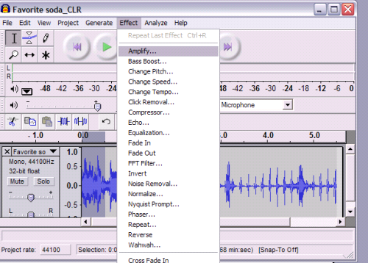

Using Audacity is time consuming, but for these cases, you truly need to transcribe each message otherwise you will miss key leads that can solve the crime or find the missing person.

Please note that Audacity does not save in .wav or mp3, so if I have to save a file where audio sound needs to be louder, I use another freeware that allows you to save in .wav or mp3 called “Free Audio Editor 2009” http://www.softpedia.com/get/Multimedia/Audio/Audio-Editors-Recorders/Free-Audio-Editor.shtml

Throughout the transcription process, some files may need further segmentation, further denoise with Clear Voice, or even audio amplification to bring hidden messages out where they can be heard.

EVP Messages I have learned appear to be compressed from the very start.

Think of a large wide rubber band. Stretch it out and write a sentence on it then release it. The sentence can barely be read now, and if you try and read it, it sounds garbled.

Segmenting files opens up that band to where the message can be understood.

For example, some of my crime case recorded files look like below.

Jane Doe November 10 2009
Jane Doe 1 November 10 2009
Jane Doe 1A November 10 2009
Jane Doe 1A1 November 10 2009
Jane Doe 1A1a November 10 2009

For this next section, I will display an existing worksheet with the victim’s name changes as well as other words, in order to show you what a file transcription worksheet looks like.

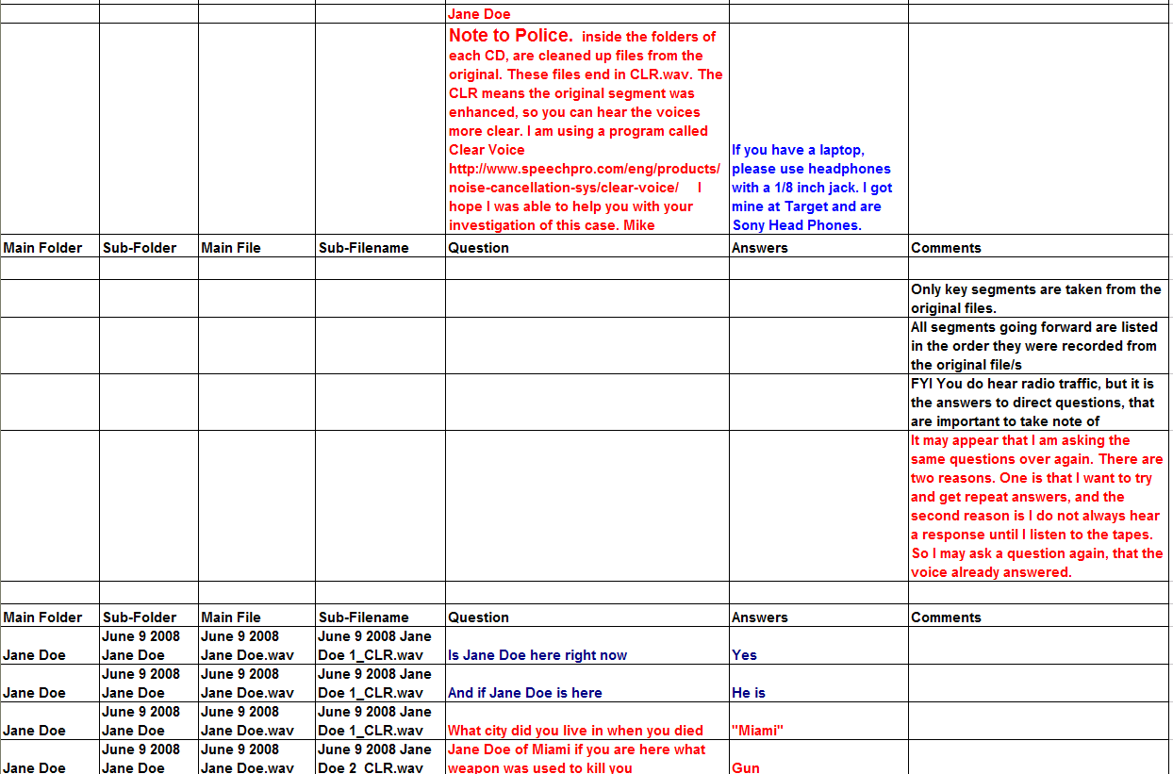

Please note that when transcribing files to a worksheet, not all files even with the de-noiser program will be clear enough to send to the client, and for this reason, after I complete a transcription, I will highlight all key files from this worksheet that I want to send to the client.

11.0 Preparing CD’s for Key Files to send to the Client

After I have completed transcribing my recorded files, I will add another worksheet within the same excel file and copy / paste over files with questions/answers that I plan to send to law enforcement/loved ones. I will date the worksheet per the mail date.

Next I will create another folder under for example, the Jane Doe main folder called “Files to LE/Loved one”, and in this folder I will create sub-folders with dates of the transcribed files tied to a particular mailing.

Before I create the CD, I will only copy over and send files with the CLR extension, as these files have been de-noised. Leaving the original files on cd only causes confusion, and the Client will not be able to hear the voices.
- For each mailing I will create one or more CD’s for the key files, as well as one CD with the Microsoft Excel worksheet.
- I also create a spare copy of each CD for my files.

.
12.0 Mailing the CD’s of the Recordings to the Client

The last part of this process is mailing the CD’s and/or e-mailing the key files to the Client.

I generally use first class mail to send these to Clients unless they request other method. “Sometimes I create a Yahoo Group and upload the files to that site making the Client a moderator.

When e-mailing, I generally mail one, two or more files at a time, but the number of files depends on the size that can be sent in Yahoo mail.
- If the files are too large for Yahoo mail, I either convert them from .wav to .mp3 or I segment them further to reduce size.

13.0 The Client/Family member is recommended to use Audacity to listen to each transcribed file.

I recommend the Client/Family member use Audacity to open up and listen to each file. Copy and past this link into a web browser and download the free software to your computer http://audacity.sourceforge.net/

Audacity is free, open source software for recording and editing sounds. It is available for Mac OS X, Microsoft Windows, GNU/Linux, and other operating systems.

I also recommend the Client/Family member get a good pair of stereo head phones, so you can listen to each file segment you block off.

It is best you open the Microsoft Excel file, and go to the transcribed file you want to listen to, and read the question and answer before you listen to the file.

After you open the file in Audacity, press the green arrow above to listen to the whole file, and then find and block off the section you want to listen to that corresponds to the transcribed file.

In Audacity, I block off small segments of recording and listen to it. For low sounding voices, I click on “Effect”, then select “Amplify”, and if the voice is too fast, I select in this same menu “Change Speed”.

For voices that are garbled and do not sound like a real word/text, I select “Reverse”, and sometimes there are messages there when reversed.

Using Audacity is very time consuming, but for these cases, you truly need to transcribe each message otherwise you miss key leads that can solve the crime or find the missing person.

14.0 Radio Hack to Enable Recording

For my EVP recording I use the Radio Shack Model 12-469 radio.

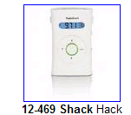

This radio has an internal speaker for ear plug listening, so to use it for EVP you will need to purchase an external speaker.

I use the Radio Shack model 21-549 external speaker.

How to set up Radio Shack Model 12-469 Radio to use for EVP-Radio Recording.
- Go to Radio Shack and buy a Radio Shack model 12-469 radio.

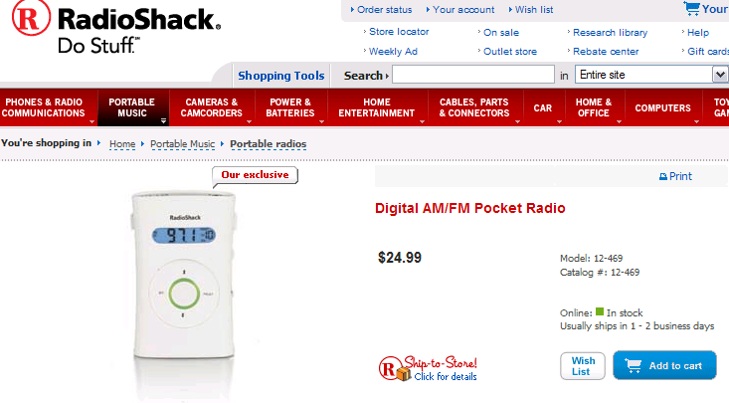

You will also need to get an external speaker if you do not already have one, and you will also need a recorder to record the messages received. I personally use an Olympus WS-100 digital recorder.

After you get your radio, go to this You Tube site to learn how to hack it.

http://uk.youtube.com/watch?v=RwvjhHd09hM

After you have your radio set up, and have your external speaker, digital recorder and stereo headphones, you are ready to start recording.

There are a number of peer EVP Radio Communities out there a beginner can learn valuable information from.

Frank Sumption’s EVP-ITC “Frank is the guy known for the EVP radio sweep device called “Frank’s Box”
http://tech.groups.yahoo.com/group/EVP-ITC/

Steve Hultay’s RTSC Real Time Spirit Communication EVP. Steve’s group teaches and tests various EVP devices
http://tech.groups.yahoo.com/group/rtsc/

Steve Hultay’s new RS Hack EVP site
http://tech.groups.yahoo.com/group/shackhacks/

Continued >>>>>>>
Steve Hultay’s Keyport Paranormal
http://www.keyportparanormal.com/franksbox13evps.html

My EVP Yahoo group is here.
http://tech.groups.yahoo.com/group/SDWR-SpeakingToTheDeadWithRadios-/

This concludes the end of my process.

If you have any questions, please send me an e-mail at f1cracker75@yahoo.com, or visit my yahoo group at http://tech.groups.yahoo.com/group/SDWR-SpeakingToTheDeadWithRadios-/

